**Project Design Phase-II Technology Architecture**

|  |  |
| --- | --- |
| **Date** | 26 October2022 |
| **Team ID** | PNT2022TMID45909 |
| **Project Name** | Plasma Donor Application |
| **Maximum Marks** | 4 Marks |

**TECHNOLOGY ARCHITECTURE:**

Technical Architecture (TA) is **a form of IT architecture that is used to design computer systems**. It involves the development of a technical blueprint with regard to the arrangement, interaction, and interdependence of all elements so that system-relevant requirements are met.

* The user interacts with the application.
* Registers by giving the details as a donor.
* The database will have all the details and if a user posts a request then the concerned blood group donors will get notified about it.

**Technology Architecture Diagram:**

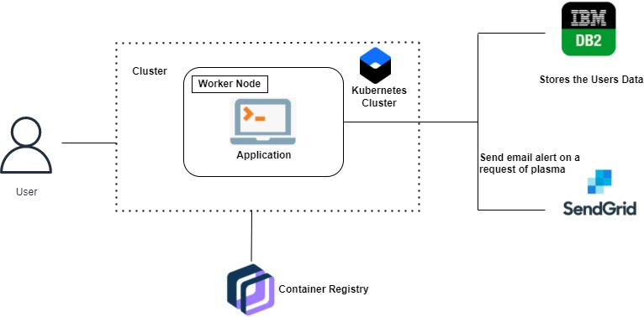

**PLASMA DONOR APPLICATION**